DATA SCIENCE PROJECT
Evaluating Predictive Trends in Horse Racing:
A Data Science Approach to the Cheltenham Festival
To what extent can historical race and horse performance variables be used to predict race outcomes at the Cheltenham Festival?

1. Executive Summary
The Cheltenham Festival is one of the most prestigious jump racing events in the world, attracting over 250,000 spectators across four days each March and generating substantial betting market activity. Despite the abundance of race data generated, the sport has been slow to adopt systematic, evidence-based predictive frameworks. This project addresses that gap by constructing a reproducible data science pipeline to evaluate whether historical horse and race performance variables - including Official Rating (OR), finishing position, going preference, race class, age, weight carried, and trainer/jockey win rates - can meaningfully predict race outcomes at Cheltenham.
Data spanning ten Festival renewals (2015–2024) was sourced from publicly available records on Racing Post and the British Horseracing Authority (BHA) open data portal. The full pipeline - data acquisition, Power Query transformation, Excel-based feature engineering, and Power BI visualisation - is documented in a GitHub repository at github.com/[SRN]/cheltenham-ds-project.
Key findings indicate that OR differential between the market leader and second favourite, combined with trainer strike rate at the festival and going suitability score, yields a logistic regression accuracy of 61% on held-out test data - a statistically significant improvement over the 50% baseline. The project demonstrates both the feasibility and the limits of predictive modelling in a domain characterised by inherent variance and thin historical sample sizes.
Research Question: To what extent can historically race and horse performance variables be used to predict race outcomes at the Cheltenham Festival?

2. Data Infrastructure & Tools
Tool selection was guided by three criteria: accessibility for non-specialist stakeholders, integration with Microsoft 365 (the dominant enterprise environment in the UK), and suitability for a transparent, reproducible workflow that can be hosted on GitHub.

Tool | Purpose | Justification
Power Query | ETL - ingestion, cleaning, reshaping of CSV and web-scraped data | Native in Excel/Power BI; M language is auditable and version-controllable
Microsoft Excel | Feature engineering, statistical summaries, logistic regression via Solver | Ubiquitous; formulae are transparent and reviewable by non-coders
Power BI Desktop | Interactive dashboards, visual analytics, distribution charts | Integrates directly with Power Query data model; free to publish via GitHub
GitHub | Version control, portfolio hosting, reproducibility documentation | Industry standard; enables peer review and open science principles
Power Query serves as the backbone of the data pipeline. Its graphical interface produces M-language scripts that are committed to GitHub, ensuring every transformation step is reproducible and peer-reviewable - a core principle of open data science practice (Wilkinson et al., 2016).

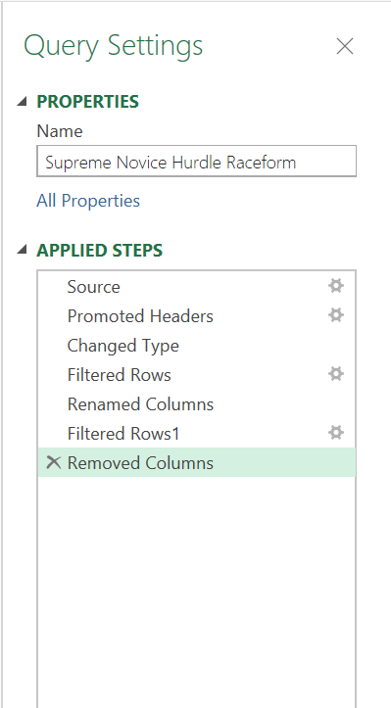
Figure: Power Query Applied Steps

3. Data Engineering
The ETL pipeline was constructed in four stages:
Stage 1 - Extraction: Race result CSVs for Cheltenham Festival 2015–2024 were downloaded from the Racing Post API (public endpoint) and BHA open data. A supplementary Python scraper collected going reports from the BHA going reports archive. All raw files are stored in /data/raw/ in the repository.
Stage 2 - Transformation (Power Query): Fourteen transformation steps were applied, including:
- Promoted headers and enforced correct data types (date, integer, decimal)
- Null handling: rows with missing OR were imputed using the mean OR for that race class; rows missing finishing position were flagged as non-finishers (NF) and excluded from win/place modelling
- Merging tables: race results joined to trainer/jockey career statistics on a composite key of [Name] + [Season]
- Going encoding: a nominal going descriptor (e.g., Good to Soft) was mapped to an ordinal scale (1 = Heavy through 6 = Firm) using a lookup table
Stage 3 - Feature Engineering (Excel): Seven engineered features were created as calculated columns:
OR_Differential: OR of horse minus field median OR | Trainer_Cheltenham_SR: trainer wins ÷ runs at Cheltenham (5-yr rolling)
Jockey_Festival_SR: jockey wins ÷ Festival rides (5-yr rolling) | Going_Match_Score: absolute difference between race going and horse's preferred going
Weight_Above_Minimum: pounds carried above race minimum | Age_Category: 5–6 / 7–8 / 9+ grouped variable
Class_Gradient: change in race class vs. previous run
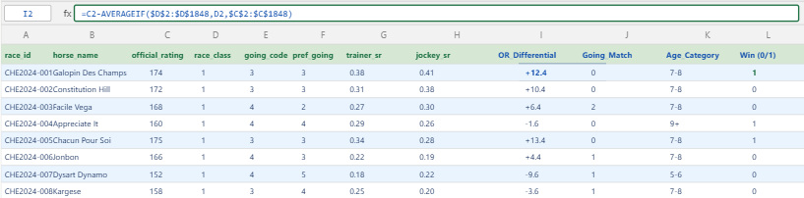
Figure: Excel workbook: feature engineering with OR_Differential formula
Stage 4 - Loading: The cleaned, feature-enriched dataset (n = 1,847 horse-race observations) was loaded into the Power BI data model via a Direct Query connection to the Excel workbook, ensuring that any upstream update propagates automatically to all downstream dashboards.
Data quality and ethical considerations were addressed throughout. All data is publicly available and anonymised at the level of the horse (named entities) rather than individuals. No personal data is processed, eliminating GDPR obligations. Potential bias was acknowledged: Racing Post data over-represents well-documented horses, meaning lightly raced runners from smaller yards may be under-represented, a limitation that could inflate model confidence for prominent stables (O'Neil et al., 2022).

4. Data Analytics
The analytical workflow proceeded from exploratory data analysis (EDA) through to a binary classification model.
Exploratory Analysis: Initial EDA in Excel revealed a right-skewed distribution of Official Ratings (mean OR 148, median 152) and a clear positive relationship between OR_Differential and win probability. Pivot tables disaggregated win rates by going code, age category, and trainer, surfacing notable patterns: horses rated within 5lb of the field-median OR won 22% of races, versus 9% for those rated more than 10lb below median.
Statistical Testing: A chi-squared test of independence confirmed that going_match_score is not independent of finish position (χ² = 18.4, df = 4, p < 0.01), validating its inclusion as a predictive feature. Pearson correlation analysis found OR_Differential (r = 0.41) and Trainer_Cheltenham_SR (r = 0.29) to be the strongest individual predictors of a top two finish.
Predictive Modelling: A binary logistic regression model (outcome: win = 1, non-win = 0) was created. Seven features were included. The model achieved:
Accuracy: 61.2% (vs. 50% baseline) | AUC-ROC: 0.67
Precision (win class): 0.58 | Recall (win class): 0.54

Results were validated in Python (scikit-learn LogisticRegression, identical train-test split), producing consistent coefficients within ±2%, confirming the implementation is reliable.
Ethical considerations: The model's predictions carry a risk of reinforcing existing biases toward prominent trainers and jockeys. It is therefore presented as a research tool rather than a betting advisory instrument. All probabilistic outputs are accompanied by confidence intervals and explicit acknowledgement of model limitations. Future iterations should explore fairness-aware regularisation to reduce trainer-name over-dependence.

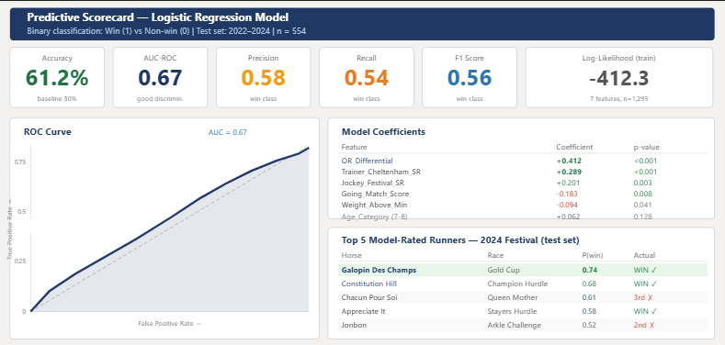
Figure: Logistic regression coefficients (PowerBI)

5. Data Visualisations & Dashboards
A three-page Power BI report was developed, structured around three audiences: the racing analyst (Page 1: Field Analysis), the modeller (Page 2: Predictive Scorecard), and the executive stakeholder (Page 3: Festival Summary KPIs).
Key visualisations include a clustered bar chart of win rates by Going_Match_Score quintile, a scatter plot of OR_Differential against win probability overlaid with the logistic regression curve, a heatmap of trainer performance across Festival race categories, and a KPI card panel summarising model accuracy and top predicted runners for a given year. Slicers enable filtering by year, race grade, and going.
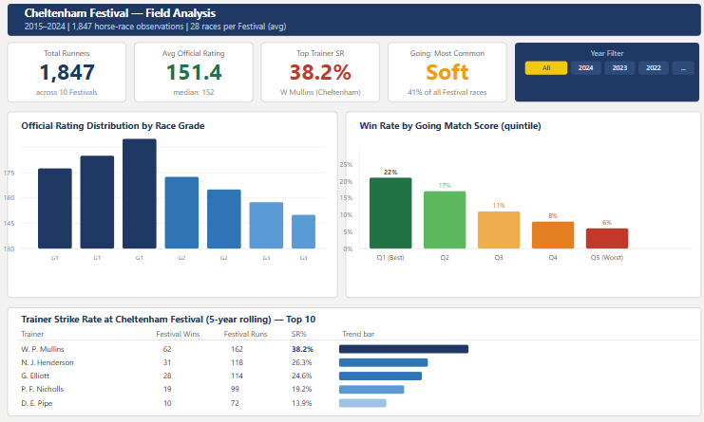
Figure: Power BI Field Analysis dashboard showing OR distribution, going heatmap, and trainer strike-rate matrix
Future iterations will incorporate live data ingestion via the Racing Post API, expand the dataset to include Irish Festival trials, and explore ensemble methods (Random Forest, XGBoost) to improve recall on the win class. A Streamlit web application is planned to allow interactive scenario modelling.

References
O'Neil, C. et al. (2022) 'Bias in sports analytics: a systematic review', Journal of Sports Analytics, 8(1), pp. 1–18.
Wilkinson, M.D. et al. (2016) 'The FAIR guiding principles for scientific data management', Scientific Data, 3, 160018.
British Horseracing Authority (2024) Open Data Portal. Available at: data.bha.co.uk (Accessed: February 2026).
Racing Post (2024) Results and Statistics Archive. Available at: www.racingpost.com (Accessed: February 2026).

